Name: ___________________________ GWUID ________________

1. Answer all questions.
2. Use short, succinct answers.
3. Do NOT copy from either the lecture notes or the textbook, but answer each question in your own words. DRAW diagram(s) to explain/clarify your answer, as necessary
4. Points per question in parentheses.
5. Justify your answers! Use full sentences.
Time Limit: 2 hours

1. Superscalar Architectures
a. Supplemental Figure 2 has an illustration of a Tomasulo example discussed in class. How does the Tomasulo algorithm accomplish register renaming?

b. Explain how the Tomasulo hardware makes maximum use of execution unit hardware, that is, keeps the functional units busy.

c. How does a reorder buffer preserve exception behavior?

2. Cache Coherency (Multiprocessors or Multicores) (10)
a) What type of cache coherency is used in massively parallel architectures and why?

b) In a snooping protocol, why are write misses always put on the bus?

3. Vector Processors:

- Explain why vector processors are much more efficient than compiler optimizations of loops and dynamic scheduling in scalar architectures.

- Briefly explain how vector units can accomplish forwarding?

4. Branch Prediction:
a. How does a branch target buffer eliminate invalid stage executions?

b. Why does a 4 state (2 bit) branch predictor do much better than a 2 state (1) branch predictor?

c. What penalties do we pay for incorrect predictions with a reorder buffer?

5. Static Code Optimization
Assume a standard MIPS architecture that we used in examples in class with branch determination and execution done in the second clock cycle for an instruction. Unroll the following loop once and schedule (re-order) the instructions to maximize processor performance. Note that the loop is correct as is, and other possible optimizations may be possible. How many cycles are required to completely execute the unrolled loop once?

loop: ld r6, 0(r1)
ld r2, 0(r8)
add r6, r6, r2
st r6, 0(r1)
daddui r1,r1, #-8
bne r5,r1, loop

6. Memory Hierarchy
a. What basic concept or concepts throughout the memory hierarchy dictate where copies of memory should be kept?

b. What happens to cache performance when the number of blocks in a direct mapped cache are reduced?

c. For b above, how does this affect other optimizations in instruction scheduling and execution units?

Supplemental Figure 1 – MIPS Pipeline with forwarding
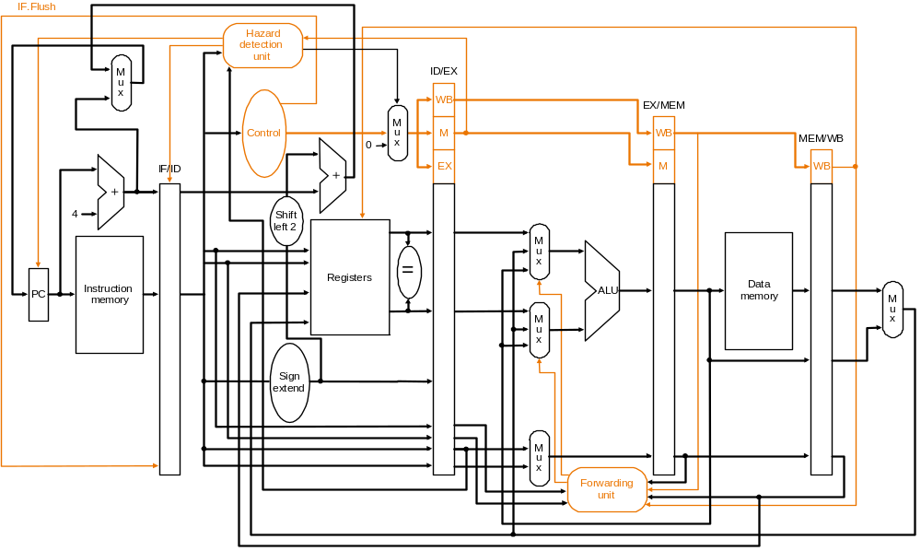

Supplemental Figure 2 – Tomasulo Example
